**Concept #1**

Players are immobile, and each have a fort of ‘blocks’. Players take it in turns to throw a projectile of some type that can either damage the opponent or destroy a block.

The main one-click mechanic is tapping to fire the projectile at the right time whilst your ‘aim’ goes back and forth (imagine the line moving up/down on the concept below).

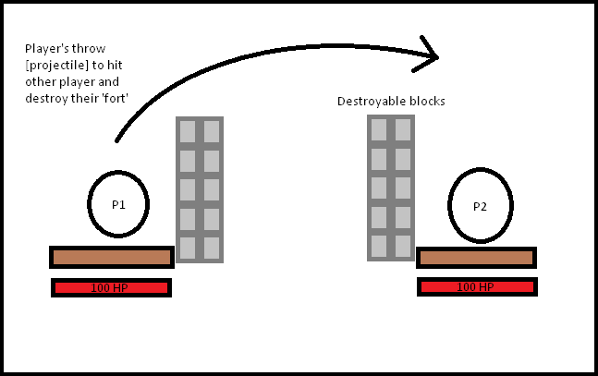

The picture is a very rough concept, the ‘forts’ would of course be more complex/useful.

Potential space for powerups, modifiers, scores.

**Concept #2**

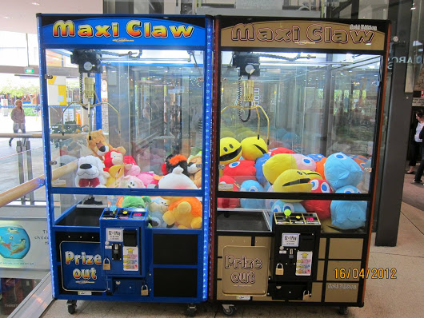Think of how ‘claw’ machines at arcades work.

The game essentially would be a claw machine, having the claw move back and forth along the top and tapping to drop the claw in its current location.

When you ‘catch’ something you add to your score based on how small/hard to catch the item was; there’s some wiggle room to add in things like powerups, different art/backgrounds/themes, and some semblance of difficulty scaling by potentially having speed settings for the claws movement.

A simple concept but something we can definitely achieve and add polish to in various forms.

**Concept #3**

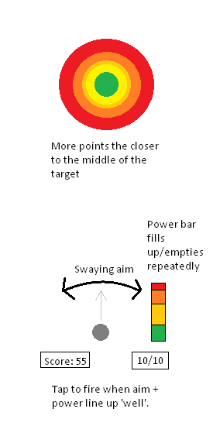2D top-down game with similar mechanics to typical 3D golf games, best explained with a picture:

Can create many different target ‘shapes’ to make players need to shoot to the sides sometimes, have the game area contained within walls so the ball will bounce off and not be possible to be out of bounds.